**E-Books Online Shop**

**Synopsis**

**Submitted to the**

\

**For the partial fulfilment of the requirement for the e-project of semester** ( II)

**DISM**

**ADSE I (2023-2023)**

**SUBMITTED BY:**

Student1372814 Maham Riaz

Student1379366 M.Abdul Aziz

Student1372812 Maria Ali Sheikh

**INSTRUCTOR NAME:**

Sir Muhammad Aqueel

**Project Title**

**E-BOOKS**

**Table of content**

|  |  |  |  |
| --- | --- | --- | --- |
| **Sr.no** | **Description** | **Page No.** | **Signature** |
| 1. | Title of Project | 2 |  |
| 2 | Acknowledgement | 4 |  |
| 3. | Introduction | 4 |  |
| 4. | Project Overview | 5 |  |
| 5. | System Analysis | 5 |  |
|  | Identification and formulation of the problem. | 6 |  |
|  | Need and significance of proposed work | 6 |  |
| 6. | Objective | 6 TO 9 |  |
| 7. | System Design | 9 TO 13 |  |
| 8. | Hardware Requirements | 14 |  |
| 9. | Software Requirements | 14 |  |
| 10. | Data Flow Diagram | 15-16 |  |

**ACKNOWLEDEMENT**

Here, we gladly present this project report on **“E-BOOK”** as part of the ( II) semester **ADSE I.** At this time of submitting this report, we use this opportunity to mention those people who with us along the work. We take this occasion to thank **God**, for blessing us with his grace and taking our work to a successful end. I want to thanks to our esteemed guide, Sir **Aqueel** for providing us with the right guidance and advice at the difficult part of our project. We also want to say thanks to our respected Head of the Aptech for allowing us to use the facilities available. We would like to thank the other faculty members also.

**Introduction:**

Our client is a famous publisher who publishes books of different categories like comics, novels, story books, General knowledge books, quiz books, journals, etc….. As there is no end for knowledge, which keeps on changing from day to day, the books are needed to be revised for every now and then. As well the stories which keep on coming as there are several writers in the world. And as there are so many publications as such and keep increasing day by day, there by increasing the competition in providing the new information, and to be first to reach out to customers. He also conducts competition for the readers by asking them to send the stories and out of the received stories the best one will be published in the next journal and as well the price will be given to the customers

**Project Overview:**

The designing of E-BOOK Project we have Used PHP, for making database file for Project. This is the project on E-PROJECT Project which is made in PHP and in Database MySQL. In E-BOOK we have used PHP SCRIPT for development and for Title we have used Database MySQL.

In E-PROJECT, we does not used complicated coding style which is easy to understand for an employee and developers. In this project the coding part is very easy to understand for employee and developers.

**Objective:**

* The Objective of this program is to give a sample project to work on real life projects. These applications help you build a larger more robust application.
* The objective is not to teach you concepts but to provide you with a real life scenario and help you create applications using the tools.
* You can revise them before you start with the project.
* It is very essential that a student has a clear understanding of the subject.
* Kindly get back to eProjects Team in case of any doubts regarding the application or its objectives.

Existing Scenario:

The publisher (client) usually publishes in the form of a hard copy (books) and in the form of a CD and distributes them to the book dealers situated all over the city, who distributes the books to the public at the maximum retail price. Some times the dealers come up saying that they want more number of copies and they again need to print the books and redistribute among the dealers based on the request of the dealers. So it takes some time in distributing the books among the dealers and then to the customers. Also he announces about the essay writing competitions, story competitions on the journal for which three days are given for the receipt of the essay writings and for the story receipt they are needed to be sent with in a week in order to attract the customers and he provides the prizes as per the competition and the winner topic and the story or the essay that he/she has sent will be published in the next publication (journal or the essay book)

**Proposed Solution:**

In order to attract and retain the customers, and to reach out to the customers early, and to stand by in this competitive world the publisher wants to build a website where the customers can register with the site and they can avail the membership benefits like getting some of the books free of cost in the form of a PDF document and as well they can place a request for purchase through online either in the form of the PDF document or in the form of a CD or in the form of a hard copy. There by reducing the delay in sending the copy to the customer as it will be directly sent to the customer’s address, instead of sending it to the book dealer and then to the customer.

The ones who purchases the book online in the form of a PDF document can have the benefits like they can access the book online and they can get the updated details as they can subscribe for a year or two or three depending on how often the book is revised. As well the PDF document that is purchased through online can only be accessed and downloaded from the site only after the receipt of the payment by the publisher.

Also the details of the books are needed mentioned including the details of the payments (includes the shipping charges (applicable for the order for a hard copy or CD and weight of that copy) or subscription charges and as well the original price of the book), Author, brief description of the book like about the book, etc…. The client says that the registered users should only be able to fetch and see the details of the books and they can alone place the order for the book.

Also he says that he want to announce the competitions for the journal and also the registered users can submit their story online through a link where one can upload the document and so that they can participate for the competition and the winners will be provided with the prize and the details of the winners will be displayed on the home page of the website. The details of the Essay writings or competitions for the journals like the date of commencing (displayed a week before of commencing), winners for the previous and the current competitions, prizes for that competition, etc…. will be displayed on the home page.

Also he says that in order to entertain children he wants to implement essay writing competition for which the topics will be provided in a separate window and the topics are needed to be displayed when it is being accessed and one needs to submit their essay writings with in 3 hrs. from the time the page is being accessed and if it is not sent by that time that particular user will not be able to submit or attend for the essay writing. Here also the winners are also announced and displayed on the site and they will be provided with some famous books either for essay writing, or G.K. books or Grammar books.

As soon as a request is placed by the customer for the purchase of a book through online, he will be intimated with a mail from the respective department regarding the order asking for the confirmation of the order placed and will be charged as per the book price and as per the revisions done to that book the customer will be asked to make the payment for the subscription as applicable for that book. And as soon as the payment is received by the publisher they will intimate the customer through mail about the receipt of the payment and as well it will be updated in the site so that the customer can access the document online.

With the varying trends in technology where one can now purchase the books or get them at free of cost online. In order to attract and retain the customers he even

In this current internet trend where one can easily purchase books online and some of the books can be attained at free of cost, so he wanted to attract his customers by providing an online portal where one can find the details of all his publications and as well one can register with the site so as to attain the benefits (like some of the books are provided free of cost for the registered users) and one can place a request for purchase of the books only when they are registered with the site and as well he says that the brief description can be seen by the unregistered users and for the detailed description of the books can be seen by the registered users.

Also the registered user can purchase the book in three types, one in the form of a PDF Document, the other in the form of a hard copy and the other in the form of a CD. For those who have placed the order for hard copy or for a CD, they will be charged for the delivery apart from the book price and it will be based on the place, weight of the book or CD.

nON-financial:

* The details of the books are needed to be captured in detail.
* Also the admin (publisher or manager of the publication) can alone have the rights to enter the details of the books like price (either free of cost or some value…), shipment or delivery charges and as well the subscription charges and their brief description.
* The details of the books and as well the details of the customers and the delivery details, shipment details and as well the details of the orders placed are needed to be stored in the database.
* Advanced search option is needed to be included so that the customer can fetch the details.
* The customers should also be able to register with the site.
* On the home page the details of the new releases and the ones that are sold at a very high rate are needed to be mentioned.
* Also the details of the winners for the previous and the current competitions and the details of the competition like the type of the competition and the date of commencing of the competition(s) that are going to be held in the near by future are also needed to be mentioned on the home page.
* The information about the books, competitions, etc…. will be only be accessed by the registered users and their complete details are to be mentioned in the appropriate link like the competitions link pages, etc……
* There should be a separate navigation link that includes the details of the competition like the topics for the essay writing and the rules and the prizes for that competition
* An advanced search option is needed to be included so that the user can fetch the details at an ease
* The orders are needed to be easily tracked down by the publisher.
* If a customer places an order through online and for a PDF Document then he/she can only be able to access that document only after the payment is received by the publisher.
* Also as soon as the order is place the customer should get the mail from the concerned department stating the receipt of the order and asking for the confirmation and as well the customer is needed to be intimated as soon as the payment is received by the publisher.
* The contact information is also needed to be provided, which includes the details of the dealers of that location, so that the customer can even purchase that book from the dealer.
* The registered customer who wanted to participate in the competition should be able to upload their essay or the story in the form of a document file from that competition link of the website.
* A Timer should be started as soon as the essay writing competition page is opened and if the time crosses 3Hrs. the customer should not be able to participate in the competition

Financial:

The customers are needed to make their payments either by Credit card or through DD or through Cheque or through VPP. And only after the receipt of the payment they can be able to access the PDF document, if placed an order for the document. Also for participating in the competition there are no charges and as well the winners are to be provided with the prizes as mentioned in the rules for that particular competition.

Functional Requirements:

* A database should be created that holds the details of the books, orders, and that of the customers.
* The customers who are registered with the site will alone be able to fetch and see the details of the website.
* The Admin solely should have the rights of uploading the details of the books and as well uploading the books in the PDF document form.
* As soon as the receipt of an order, the customer should be acknowledged with the details of the order, like address (if ordered for the CD or Hard copy) and then ask for the confirmation of the order.
* After the confirmation is received from the user, then only the further process has to be taken place.
* The customer who has requested for the book online in the form of the PDF Document, can only access that document only after the payment is received by the publisher.
* The contact information is also needed to be provided, which includes the details of the dealers of that location, so that the customer can even purchase that book from the dealer.

**Problem Statement**

Problem statement is attached separately in a file “**E-Books**”

**Standards plan:**

Every code block must have comments.

The logic of the program needs to be explained. Proper documentation should be maintained.

Complete Project Report along with synopsis, code and documentation should be prepared.

**Documentation:**

No project is complete without documentation. In fact, it is one of the most important activities during the development of a project. The documentation of an ideal project will be in the form of a project report comprising of the following documents:

* Certificate of Completion.
* Table of Contents.
* Problem Definition.
* Customer Requirement Specification.
* Project Plan.
* E-R Diagrams.
* Algorithms.
* GUI Standards Document.
* Interface Design Document.
* Task Sheet.
* Project Review and Monitoring Report.
* Unit Testing Check List.
* Final Check List.

**Hardware/ Software Requirements**

**Hardware :**

* A minimum computer system that will help you access all the tools in the courses is a Pentium 166 or better
* 128 Megabytes of RAM or better

**Operating System:**

* LINUX / Windows 2000 Server (or higher if possible)

**Software :**

* PHP
* MySQL
* PERL
* Apache

**Introduction**

The thirst for learning, upgrading technical skills and applying the concepts in real life environment at a fast pace is what the industry demands from IT professionals today. However busy work schedules, far-flung locations, unavailability of convenient time-slots pose as major barriers when it comes to applying the concepts into realism. And hence the need to look out for alternative means of implementation in the form of laddered approach.

The above truly pose as constraints especially for our students too! With their busy schedules, it is indeed difficult for our students to keep up with the genuine and constant need for integrated application which can be seen live especially so in the field of IT education where technology can change on the spur of a moment. *Well, technology does come to our rescue at such times!!*

Keeping the above in mind and in tune with our constant endeavour to use Technology in our training model, we at Aptech have thought of revolutionizing the way our students learn and implement the concepts using tools themselves by providing a *live and synchronous eProject learning environment!*

**So what is this eProject?**

eProject is a step by step learning environment that closely simulates the classroom and Lab based learning environment into actual implementation. It is a project implementation at your fingertips!! An electronic, live juncture on the machine that allows you to

* Practice step by step i.e. laddered approach.
* Build a larger more robust application.
* Usage of certain utilities in applications designed by user.
* Single program to unified code leading to a complete application.
* Learn implementation of concepts in a phased manner.
* Enhance skills and add value.
* Work on real life projects.
* Give a real life scenario and help to create applications more complicated and useful.
* Mentoring through email support.

The students at the centre are expected to complete this eProject and send complete documentation with source code to eProjects Team

Looking forward to a positive response from your end!!

The Objective of this program is to give a sample project to work on real life projects. These applications help you build a larger more robust application.

The objective is not to teach you concepts but to provide you with a real life scenario and help you create applications using the tools.

You can revise them before you start with the project.

It is very essential that a student has a clear understanding of the subject.

Kindly get back to eProjects Team in case of any doubts regarding the application or its objectives.

**Objectives of the project**

**Problem Statement**

Problem statement is attached separately in a file “**E-Books**”

**Standards plan:**

Every code block must have comments.

The logic of the program needs to be explained. Proper documentation should be maintained.

Complete Project Report along with synopsis, code and documentation should be prepared.

**Documentation:**

No project is complete without documentation. In fact, it is one of the most important activities during the development of a project. The documentation of an ideal project will be in the form of a project report comprising of the following documents:

* Certificate of Completion.
* Table of Contents.
* Problem Definition.
* Customer Requirement Specification.
* Project Plan.
* E-R Diagrams.
* Algorithms.
* GUI Standards Document.
* Interface Design Document.
* Task Sheet.
* Project Review and Monitoring Report.
* Unit Testing Check List.
* Final Check List.

**Hardware/ Software Requirements**

**Hardware:**

* A minimum computer system that will help you access all the tools in the courses is a Pentium 166 or better
* 128 Megabytes of RAM or better

**Operating System:**

* LINUX / Windows 2000 Server (or higher if possible)

**Software:**

* PHP
* MySQL
* PERL
* Apache

**Hardware Requirements:**

|  |  |
| --- | --- |
| **Number** | **Description** |
| 1 | PC with 2 GB hard-disk and 512 MB RAM |
| 2 | Hard disk: 500GB |

**Software requirements:**

|  |  |
| --- | --- |
| **Number** | **Description** |
| 1 | Windows 10 with Visual Studio Code, PHP, MySQL and Apache |
| 2 | Microsoft Word |

**DFD (Data Flow Diagram):**

A data flow diagram (DFD) is a graphical representation of the "flow" of data through an information system, modelling its process aspects. A DFD is often used as a preliminary step to create an overview of the system, which can later be elaborated.

Entity Relationship Diagram

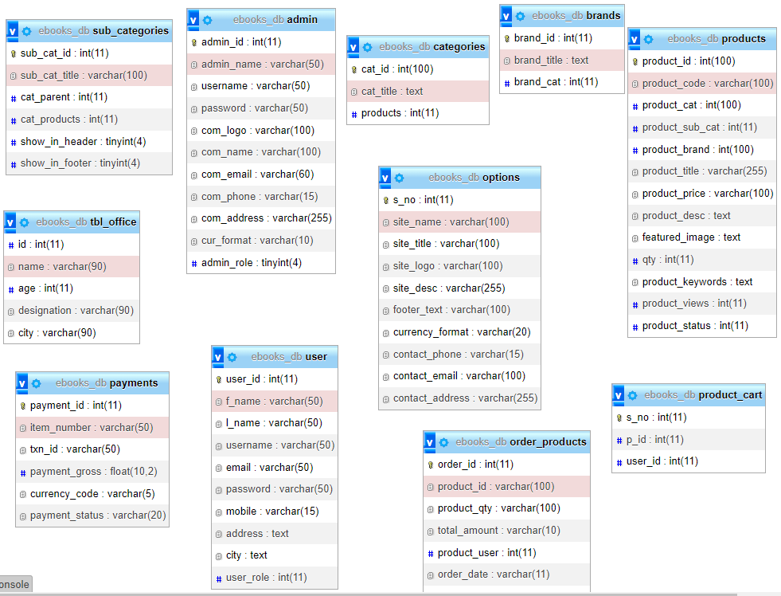

**DFD Diagrams:**

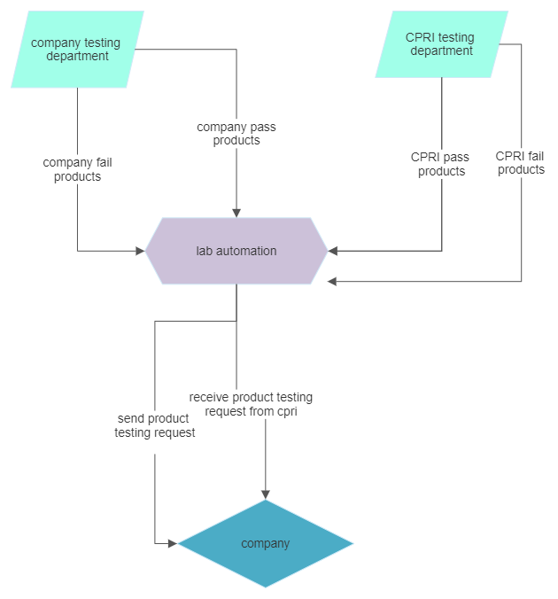

**ADMIN FLOWCHART**

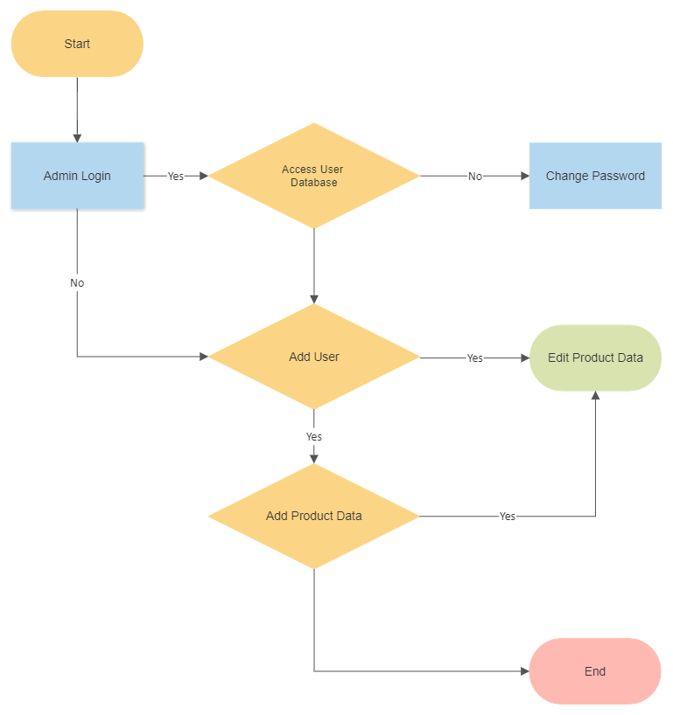

**LOGIN FLOWCHART**

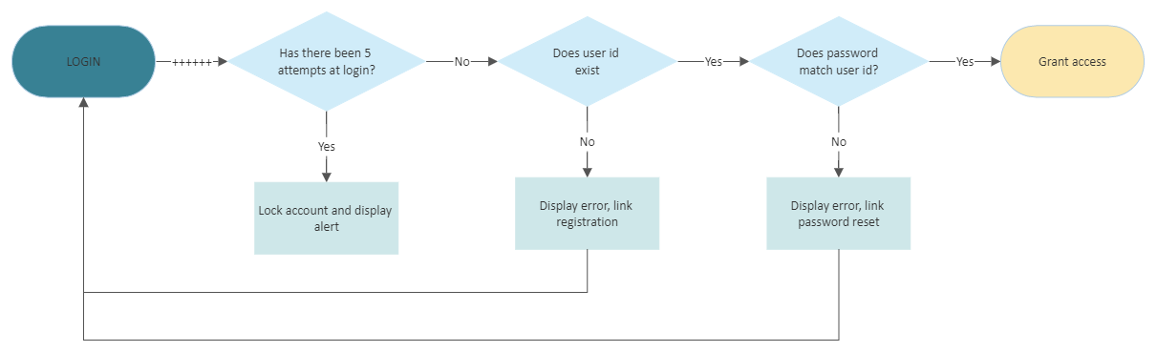

**PRODUCT FLOWCHART**

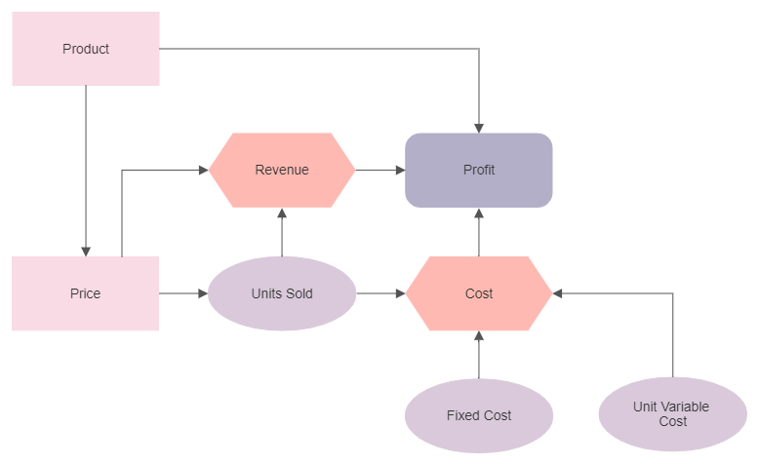

**USER FLOWCHART**

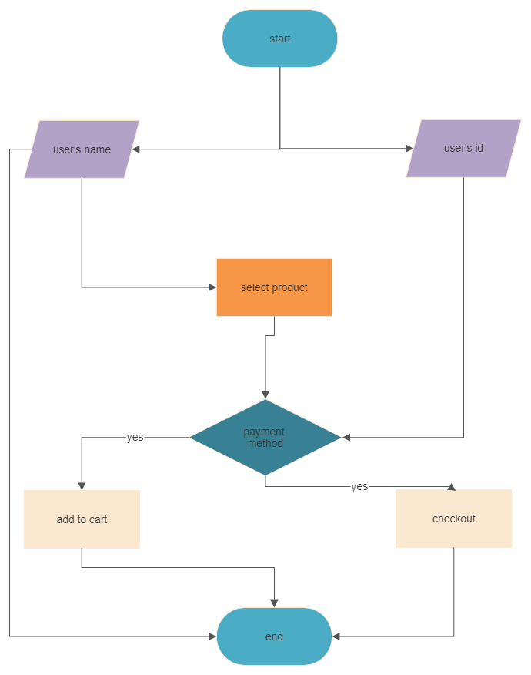

**SCREENSHOTS**

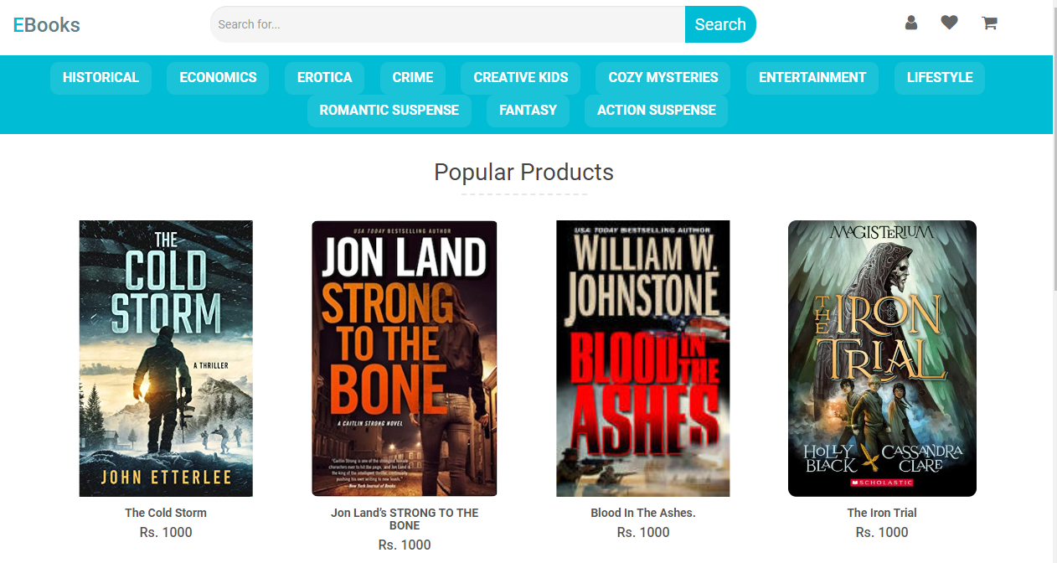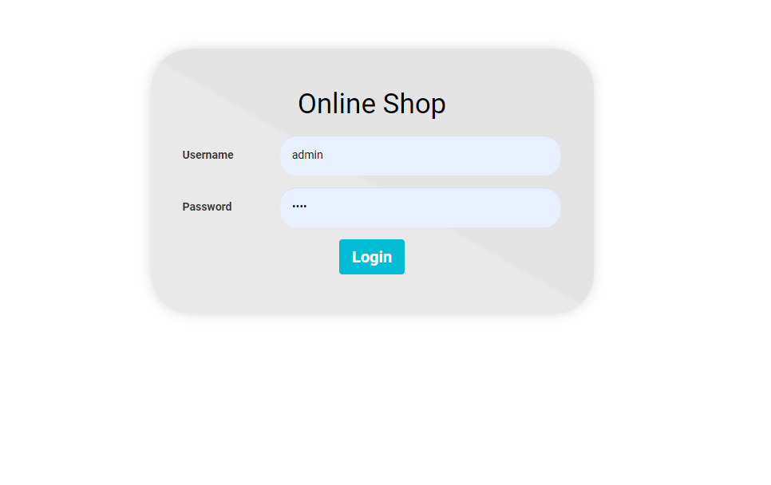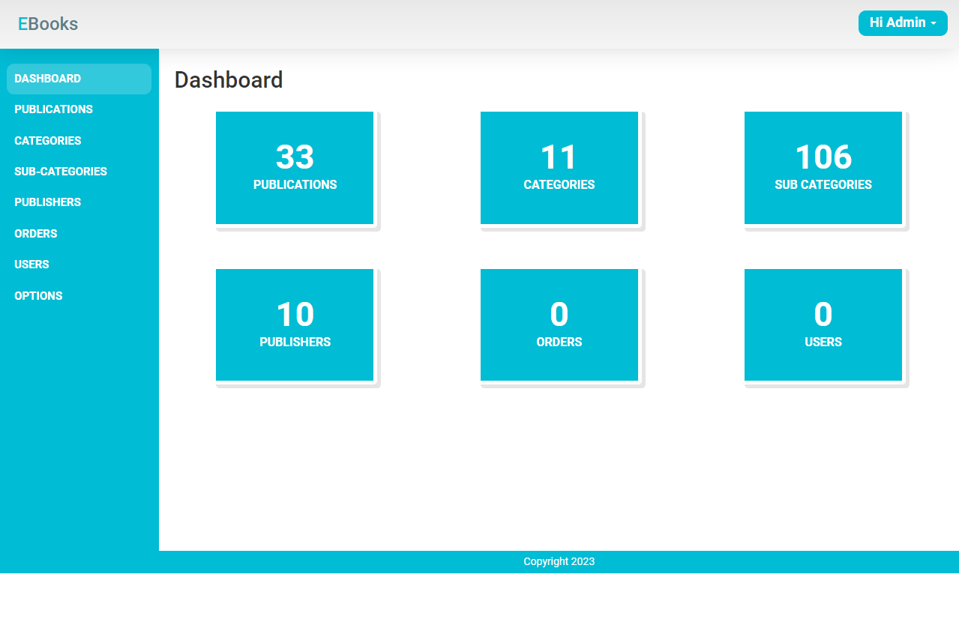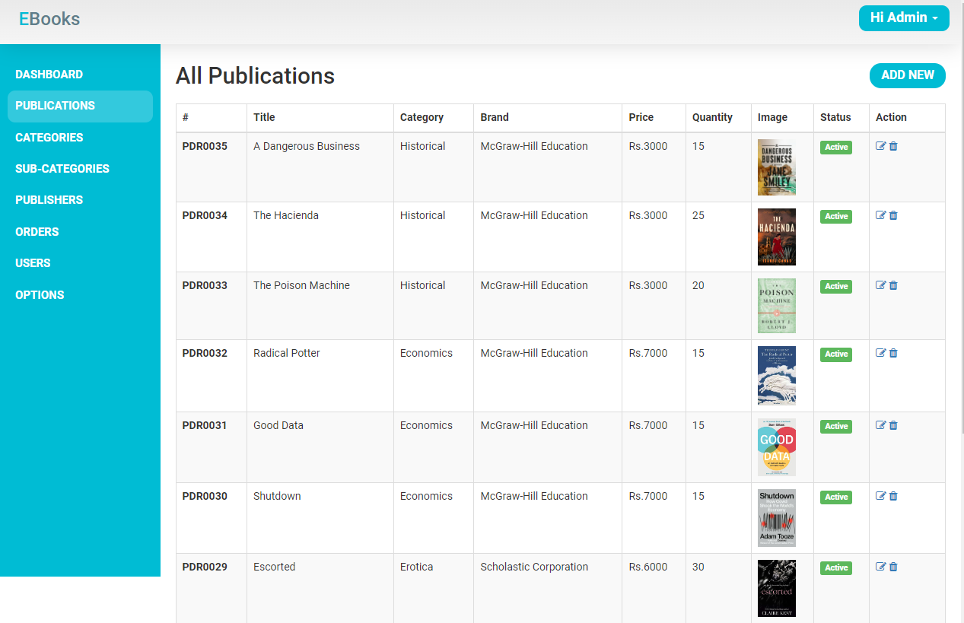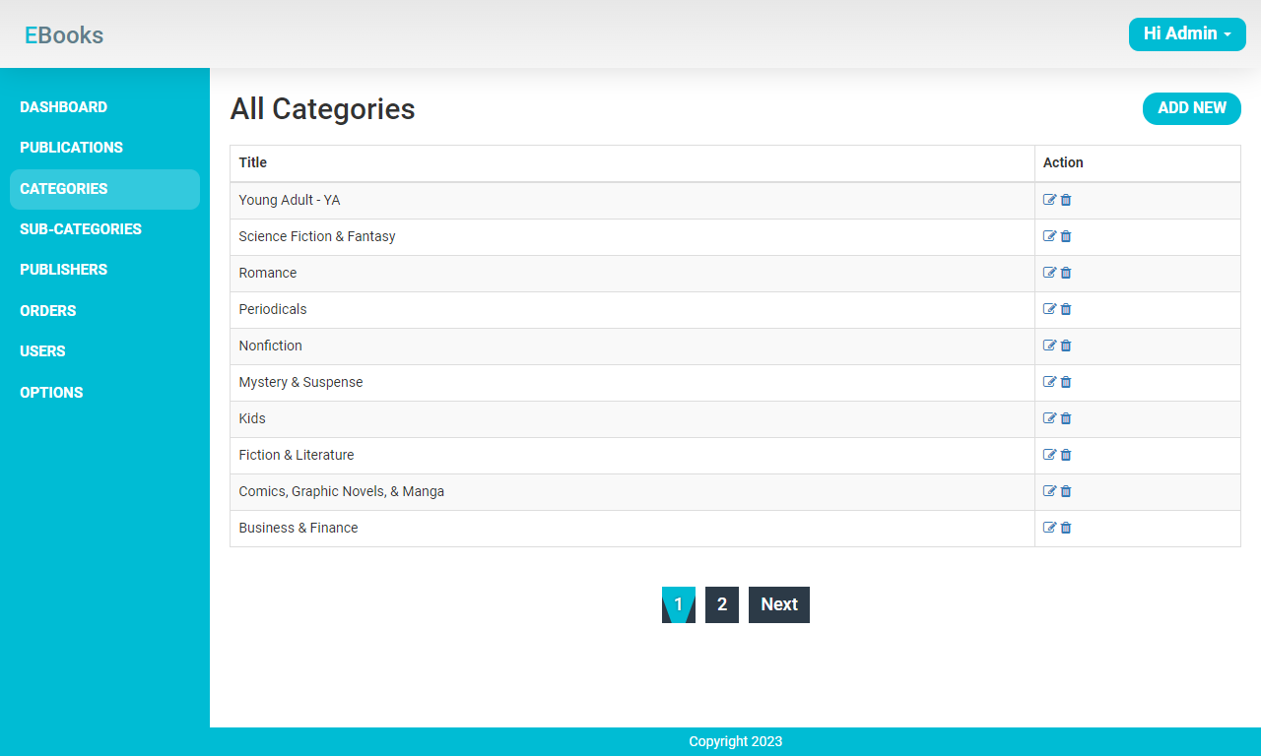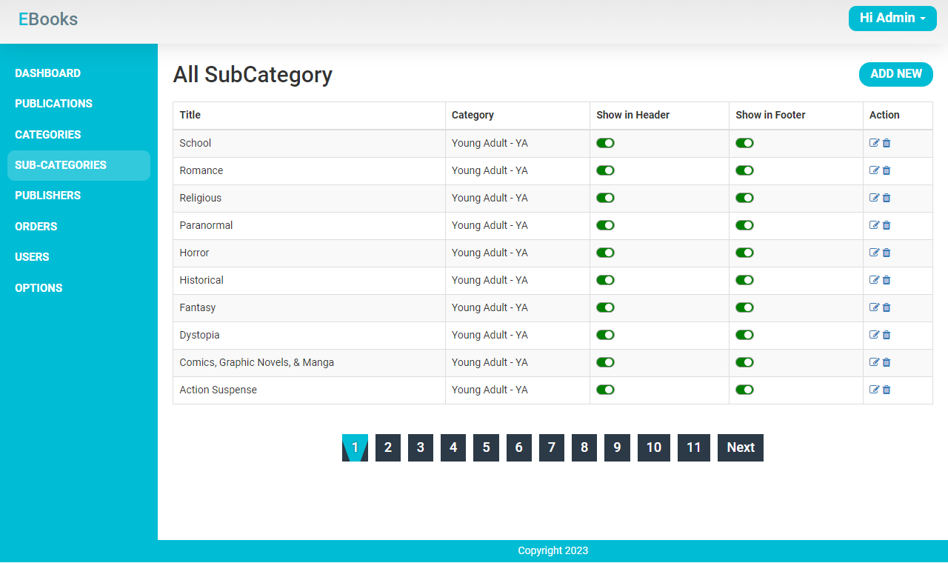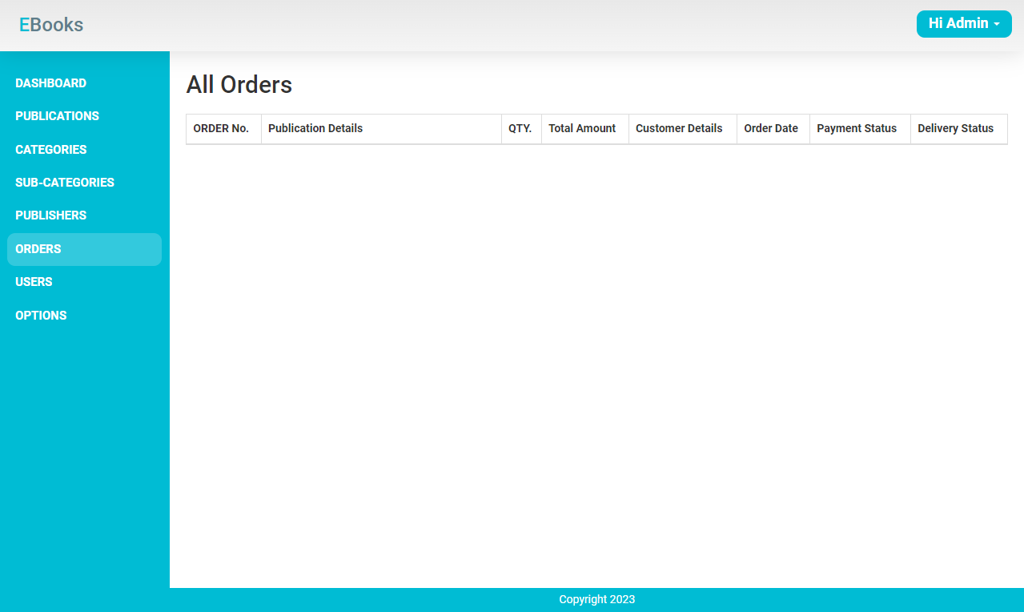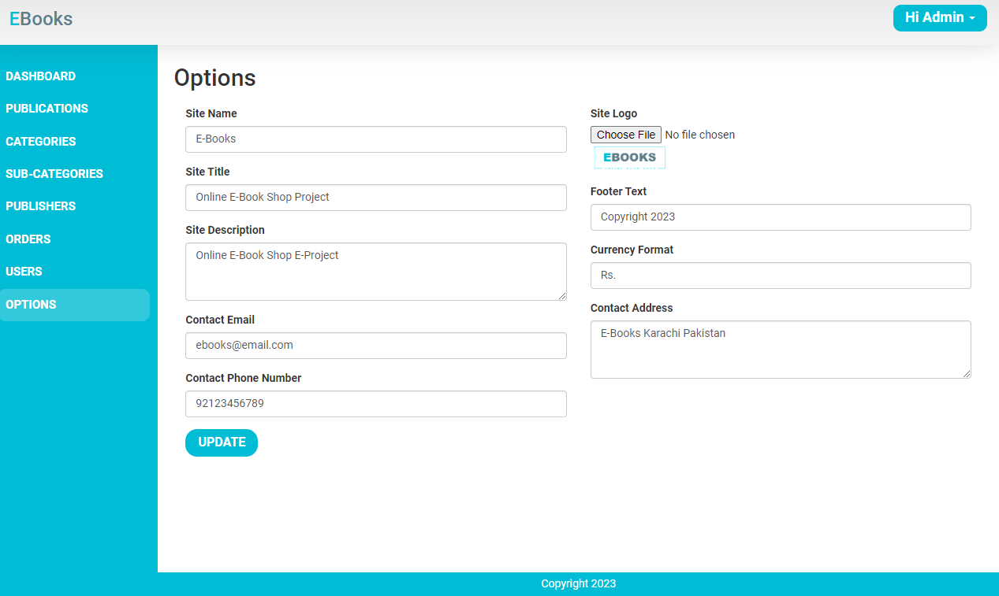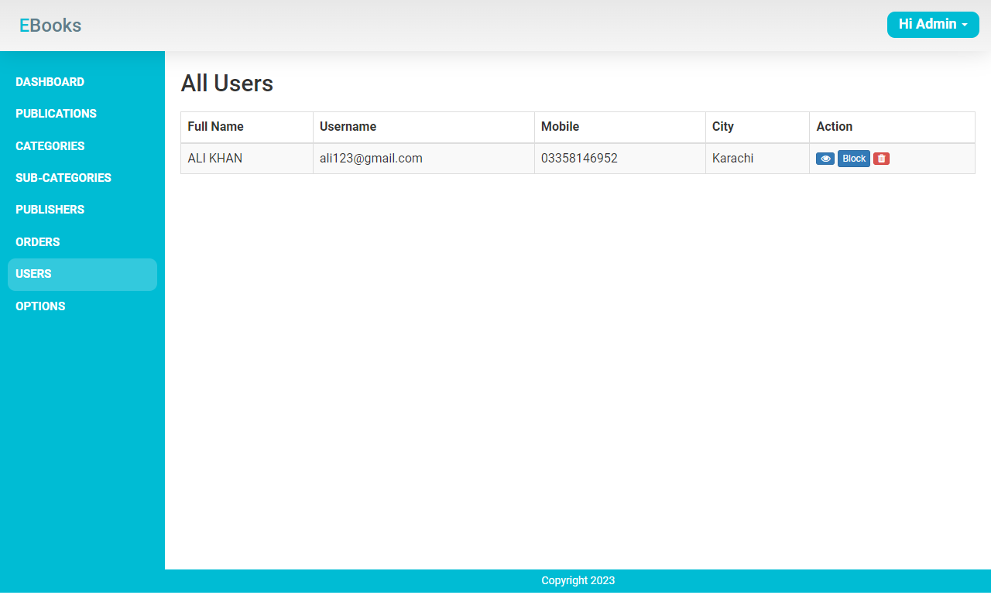

**SOURCE CODE**